Chapter 3.7

* Every geom has a default stat, and every stat has a default geom
  + You can usually use geoms without worrying about the underlying statistical transformation
* You can override the defaults if you want to

3.7.1 Exercises

1. The default geom is geom_pointrange(). It can be rewritten as following:

ggplot(data = diamonds) +

+ geom_pointrange(mapping = aes(cut, y = depth),

+ stat = 'summary', fun.ymin = min, fun.ymax = max, fun.y=median)

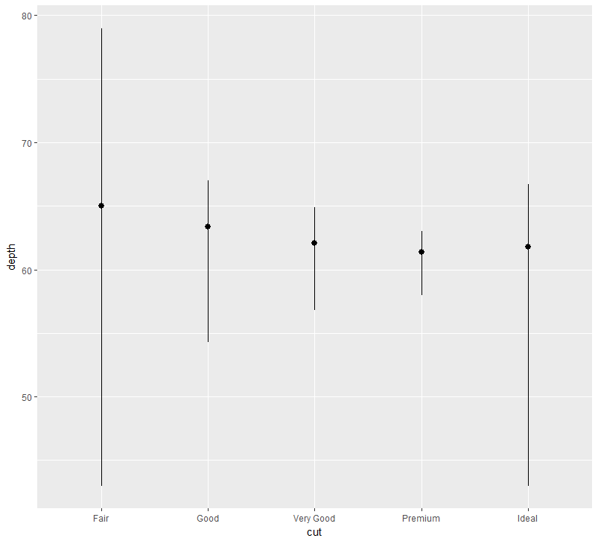

1. They both do the same thing, graphing a bar graph. Geom_bar() will use the stat_count() in order to draw the bar graph. Geom_col() will assume that the data has already been transformed into usable data.
2. geom_freqpoly(mapping = NULL, data = NULL, stat = "bin",

position = "identity", ..., na.rm = FALSE, show.legend = NA,

inherit.aes = TRUE)

geom_histogram(mapping = NULL, data = NULL, stat = "bin",

position = "stack", ..., binwidth = NULL, bins = NULL, na.rm = FALSE,

show.legend = NA, inherit.aes = TRUE)

stat_bin(mapping = NULL, data = NULL, geom = "bar", position = "stack",

..., binwidth = NULL, bins = NULL, center = NULL, boundary = NULL,

breaks = NULL, closed = c("right", "left"), pad = FALSE,

na.rm = FALSE, show.legend = NA, inherit.aes = TRUE)

1. Stat_smooth will compute the predicted variable, lower pointwise, upper pointwise, and standard error.
2. 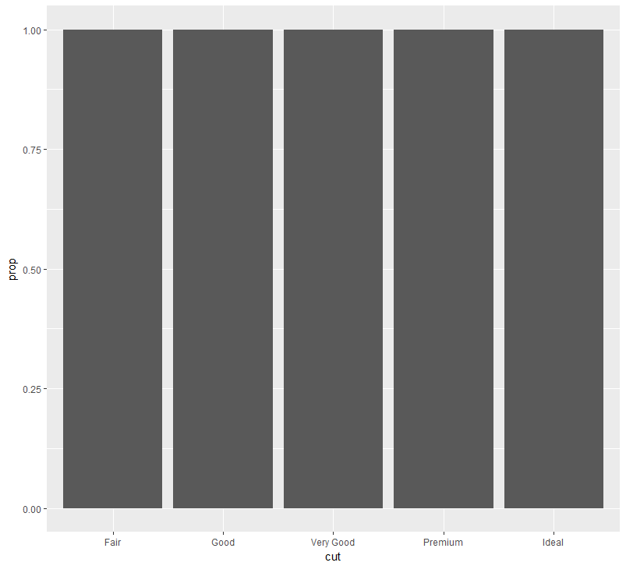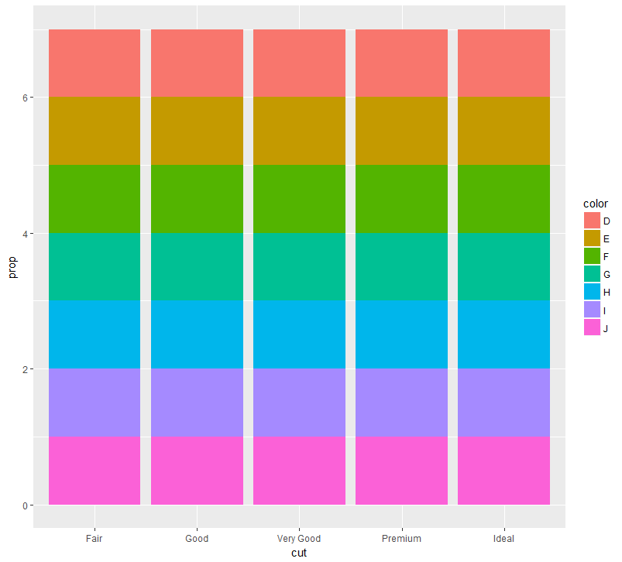 If we don’t set group to 1, then the graph will set proportions related to the entire data set, rather than the desired “cut”. We want the graphs to look more like this:

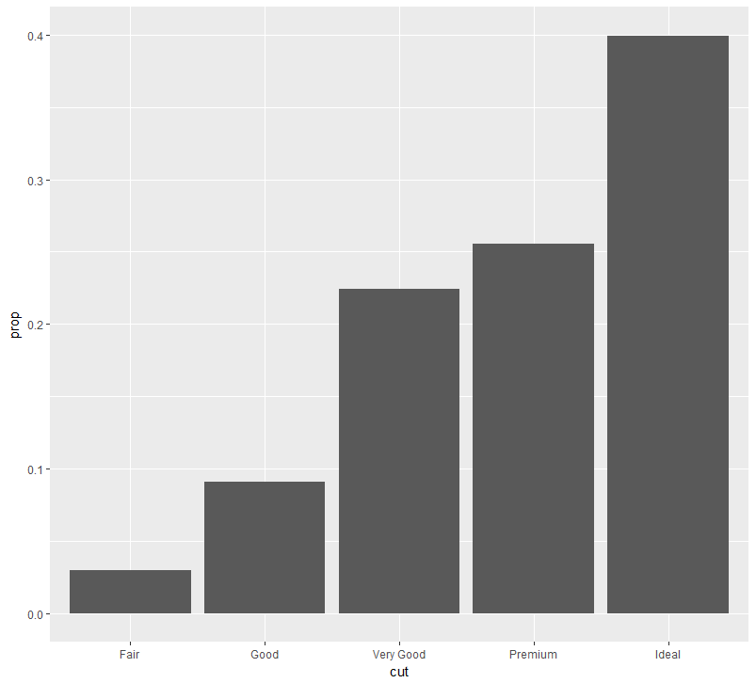

3.8

* Coloring a bar graph is done using the color aesthetic or the fill aesthetic.
  + The color aesthetic will change the color of the border of the bars, and the fill changes the fill color.
* Bars will automatically stack with the introduction of another variable
  + If this is undesired, one can perform a position adjustment using the position argument
  + “identity”, “dodge”, or “fill”
* “Identity” will automatically put the bars exactly where they should be, overlapping each other.
  + Difficult to see the data without using at least some form of transparency.
* “Fill” works just like stacking, but will make each set of bars the same height
* “Dodge” will put overlapping data next to each other
* Position “jitter”, not useful for bar graphs, can be used for scatter plots. It will cause the dots to overlap each other.

3.8.1 Exercises

1. Some of the points overlap and hide each other. A simple fix would be to use the “jitter” position method.

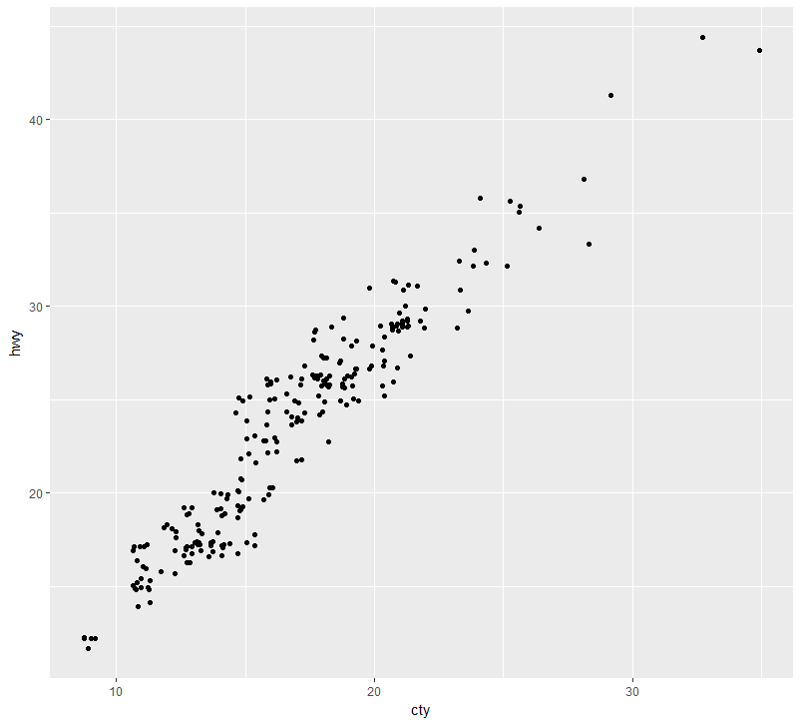

1. In order to control the amount of jittering, you can use the parameters of width, height, and position.
2. Geom_jitter() will randomly move the points to prevent said points from overlapping each other. Geom_count() will count the number of points and plot them to a single point.
3. The default position adjustment for geom_boxplot() is position_dodge. Demonstration: 